Screen mock up:

Once we hosts the web application initial screen is Index page

Index view :

It should get the list of tasks and its details like that, here we should have the way to Edit, create, Details and Delete. It will go to the separate view page to execute the actions.

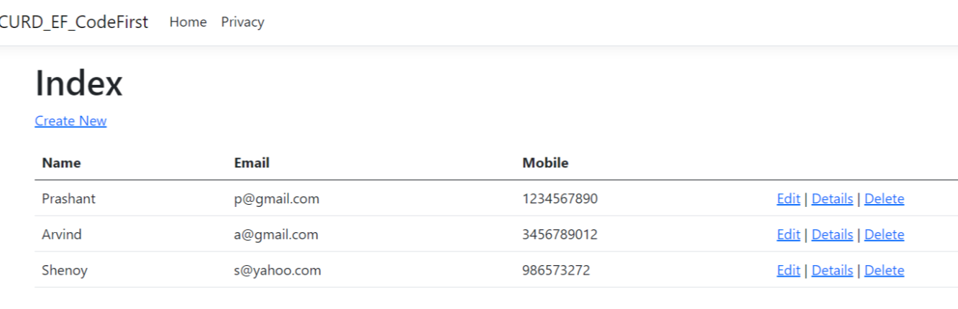

Details View:

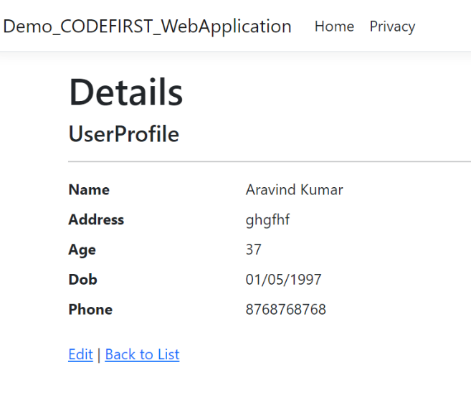

It should list the data which we already in Database like this and screen should have option for Edit the data and Go back to previous List ( Index page)

On click of Edit link it should go to Edit view page and fields to be editable in text box format.

Edit View:

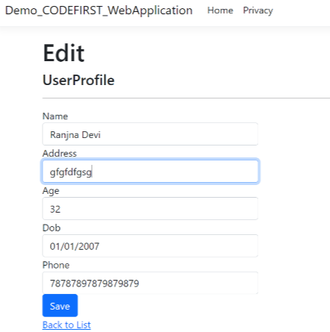

Edit screen should allow you to change existing data and save the new data to db through Save button and also to go back to the Index page through link.

Delete:

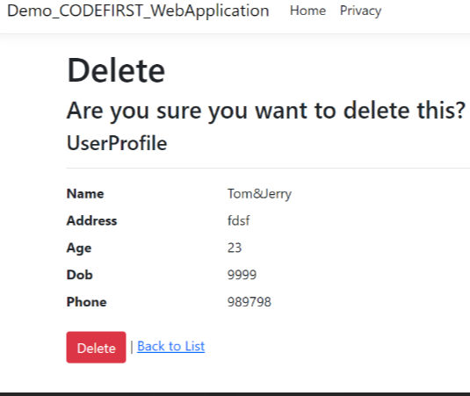

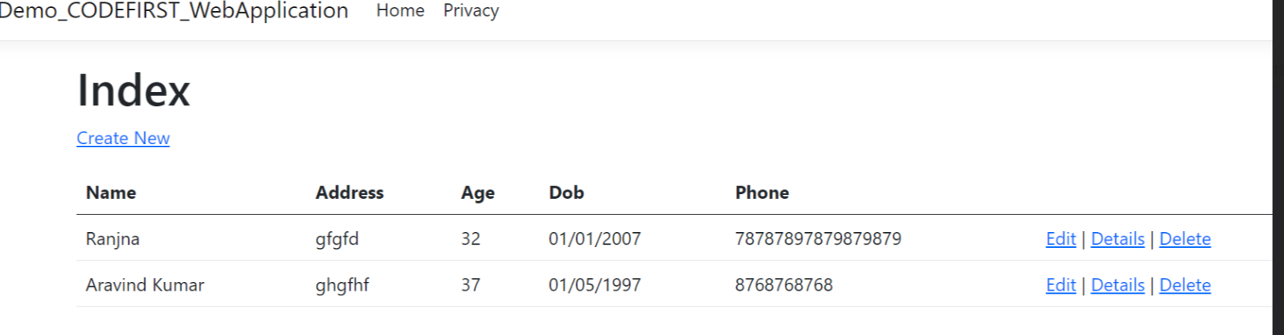

Delete screen will delete the existing entry by this view and if we click on Delete the entry should not be in the table anymore.

Create New:

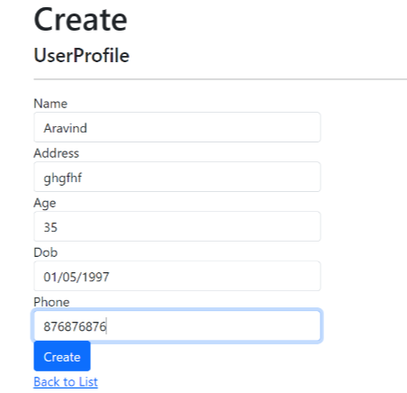

Create screen will let us to add the new tasks like that and if we click Create button data will be added to the list. And Back to list should give like Index page

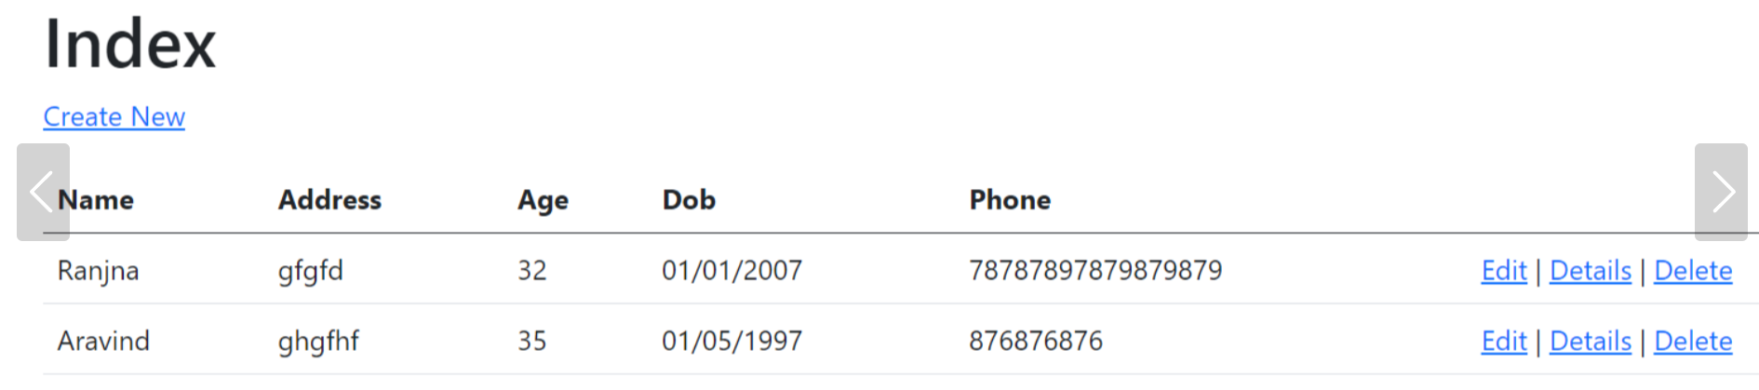

Flow Chart for Create new task

Request (Task/Create)

Route.Config in App_start

User

Database

Create.cshtml /Create.razor (View)

Model Associated with Task Controller (Datamodel)

Search for the Action Result method with Create

Task Controller

Displays list of tasks with added new task

Index View

Save button.